CMPS 312 Mobile App Development

**Assessment # 1**

|  |  |
| --- | --- |
| **Student Name** | Leina Elsheiri |
| **Student Id** | 202005197 |
| **Email** | Le2005197@qu.edu.qa |

**Grading Rubric - - In the *Functionality* column please specify either: *Working (completed x%)*, *Not Working (completed x%)* or *Not done*.**

|  |  |  |  |  |
| --- | --- | --- | --- | --- |
| Criteria | % | % Functionality | Instructor Feedback | Score |
| Q1.   * Book Class Implementation * BooksRepo Class Implementation * Extension Methods | 50% |  |  |  |
| Q2 –   * Customer Class Implementation * Account Class Implementation * SavingsAccount and CurrentAccount Classes * Mixin Implementation * Taxable Interfacec | 50% |  |  |  |
| Testing Sheet  Testing Sheet is Mandatory! Failure to submit the testing sheet along with your assignment will result in a 10% deduction from your total grade. Ensure that all required outputs are included in the testing sheet before submission. | -10 |  |  |  |
| Total | 100 |  |  |  |
| Copying and/or plagiarism or not being able to explain or answer questions about the implementation | -100 |  |  |  |
|  |  |  |  |  |

**Possible grading for functionality**:

* ***Complete and Working*** (get 70% of the assigned grade),
* ***Complete and Not working*** (lose 40% of assigned grade)
* ***Not done*** get 0.
* The remaining grade is assigned to the quality of the implementation.
* Must submit screenshots in this **Testing-GradingSheet.docx** (otherwise - 10pts).

1. **Q1 output**

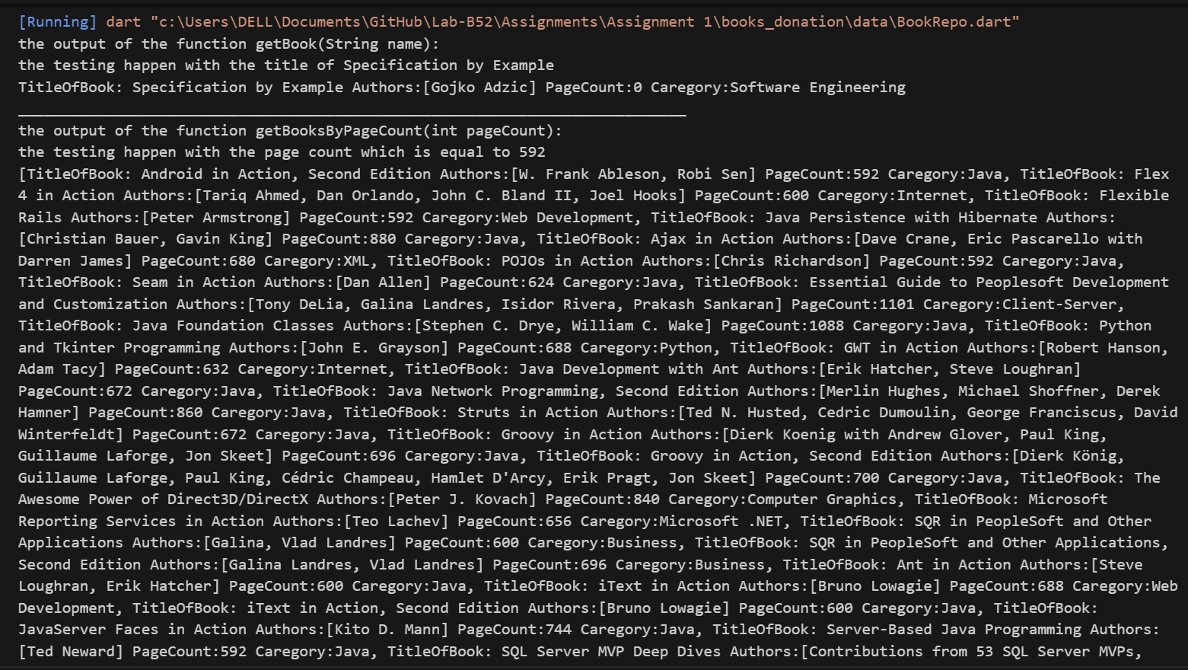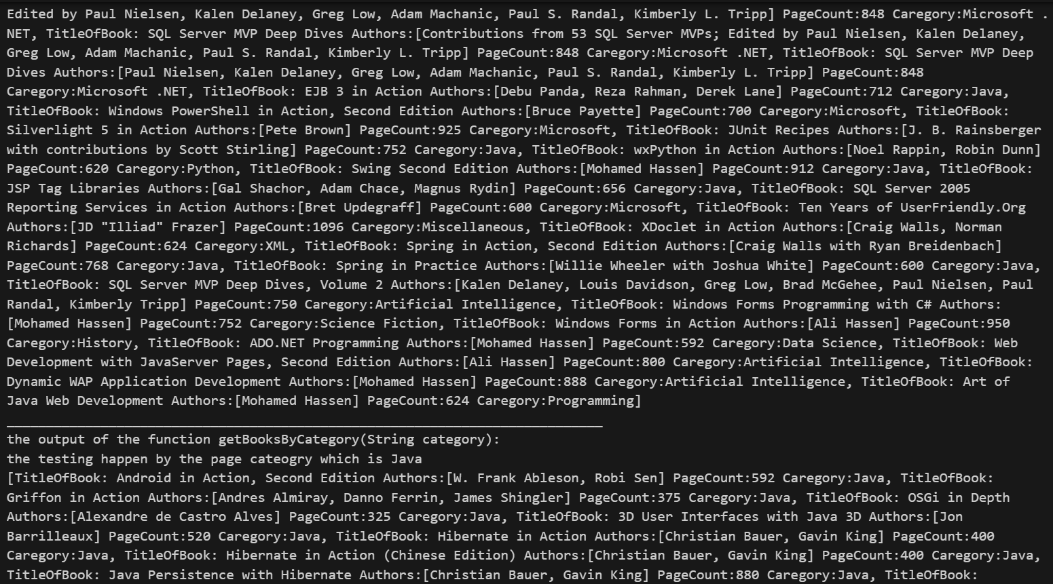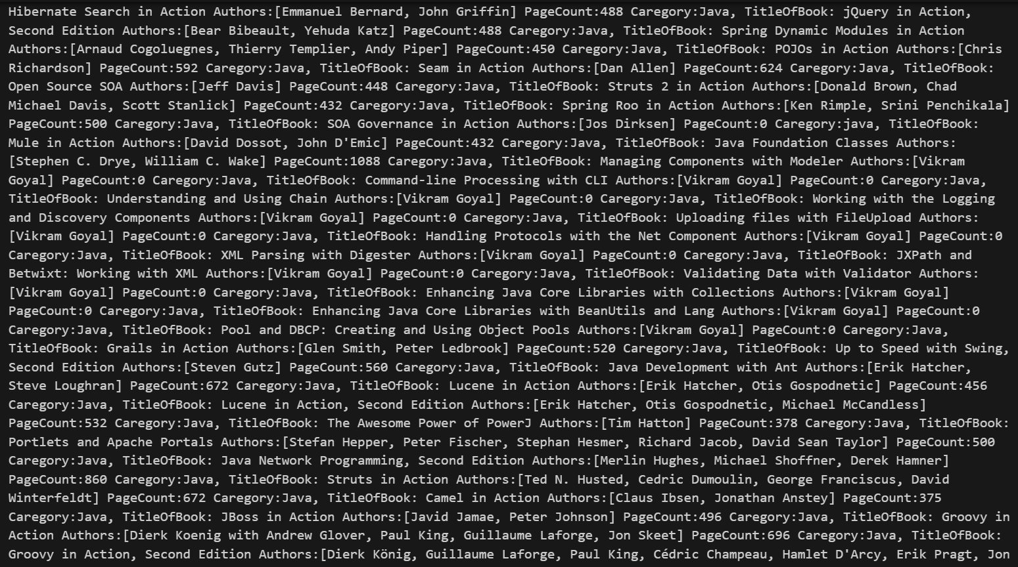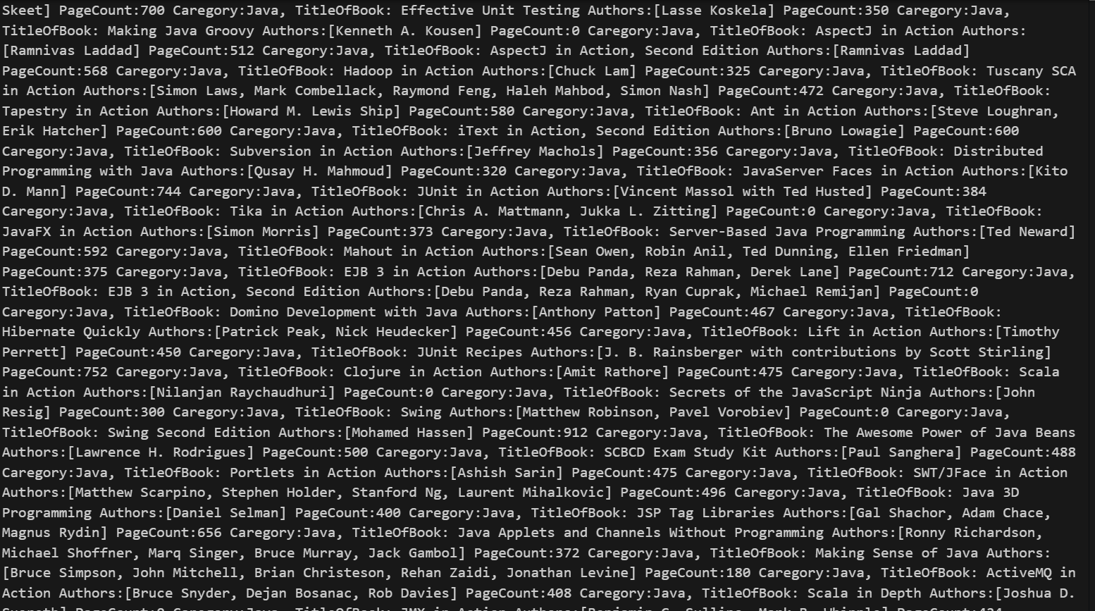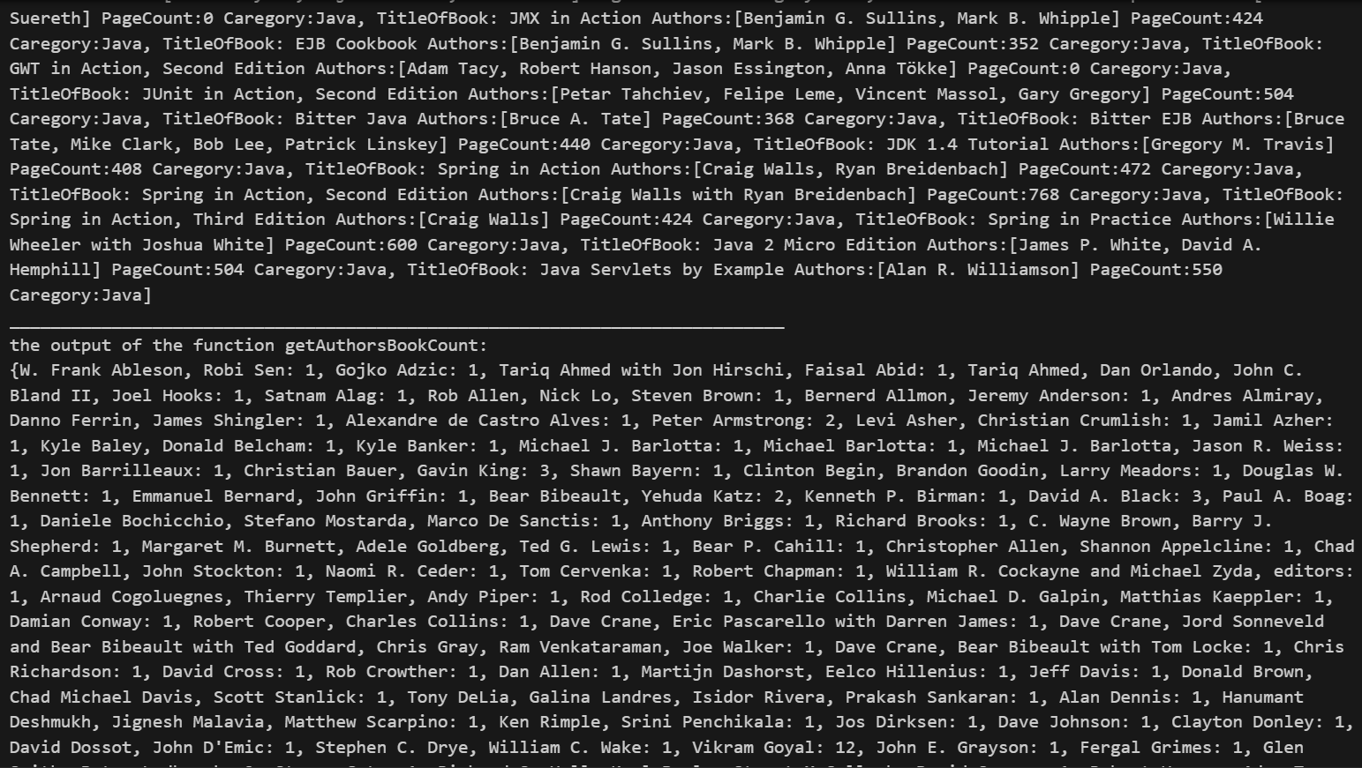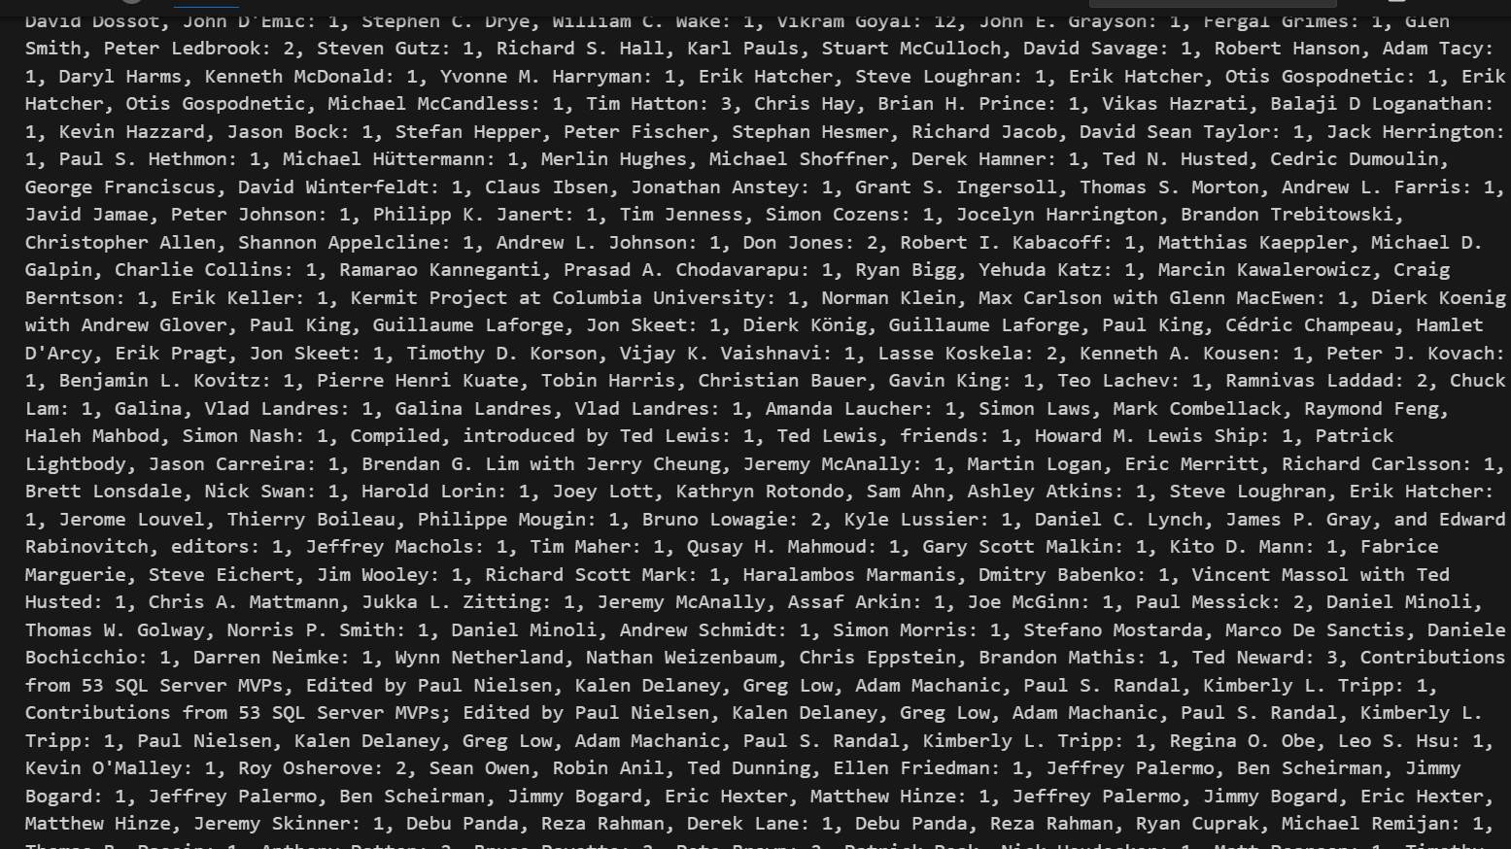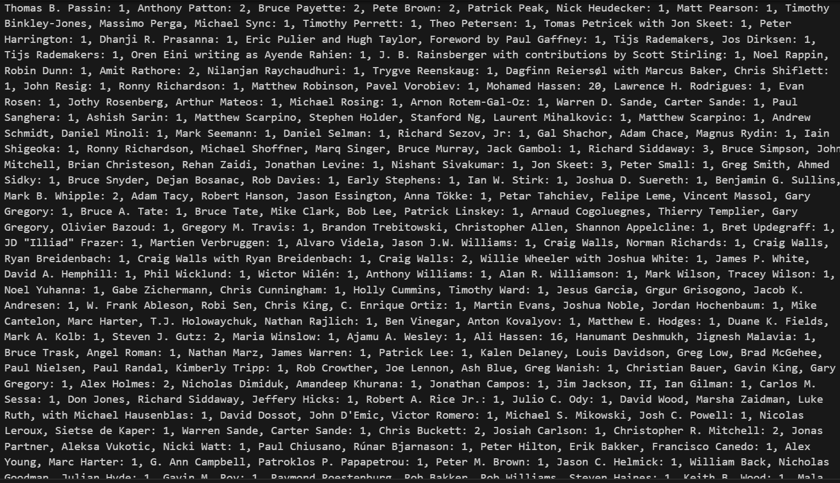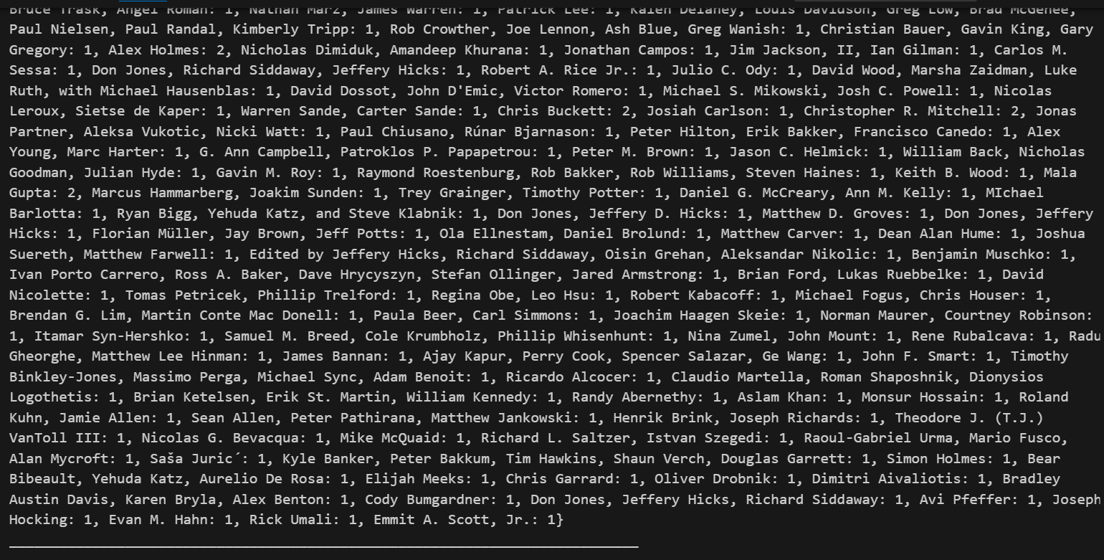

1. **Q2 output**